**Step 1: Create a Windows Virtual Machine in Azure**

1. **Log in to the Azure Portal**:
   * Navigate to the [Azure Portal](https://portal.azure.com) and sign in with your Azure account.
2. **Create a New Virtual Machine**:
   * Click on **"Create a resource"** from the left-hand menu.
3. **Configure the VM Basics**:
   * **Subscription**: Choose your subscription.
   * **Resource Group**: Either create a new resource group or select an existing one.
   * **Virtual Machine Name**: Provide a name for your VM.
   * **Region**: Select **"West US"** from the dropdown menu.
   * **Availability Options**: Choose your preferred option based on redundancy needs.
   * **Image**: Ensure you have selected a Windows Server image.
   * **Size**: Select the appropriate VM size for your requirements.
4. **Configure Administrator Account**:
   * Choose the **Authentication type** (Password is commonly used).
   * Enter a **Username** and a **Password** that meets the complexity requirements.
5. **Configure Networking**:
   * In the **Networking** tab, ensure a new virtual network and subnet are created or select existing ones.
   * Make sure to allow **Public IP** for external connections.
6. **Open RDP Port**:
   * In the **Networking** section, add an inbound port rule to allow **RDP (port 3389)**.
     + **Source**: Any (or specific IPs if you want to restrict access)
     + **Protocol**: TCP
     + **Port Range**: 3389
     + **Destination**: Any
7. **Review + Create**:
   * Review all settings and click **"Create"** to provision the VM. This may take a few minutes.

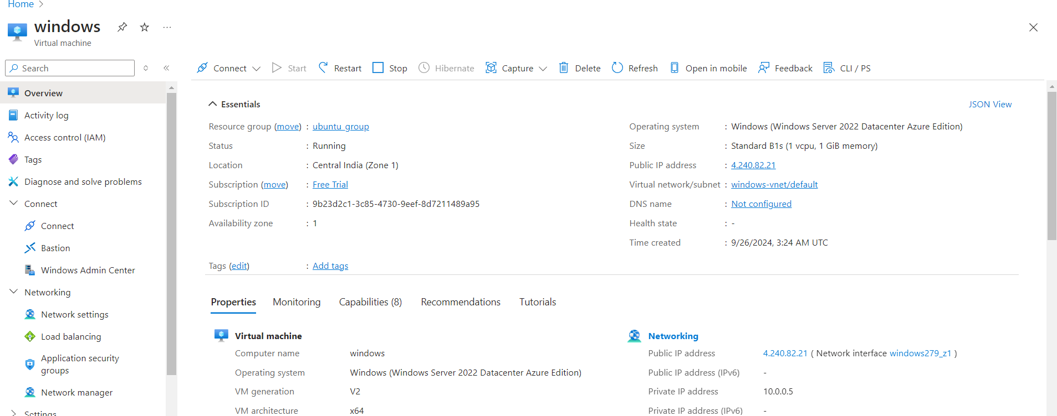

**Step 2: Connect to the Windows VM using Remote Desktop**

1. **Get the Public IP Address**:
   * Once the VM is created, navigate to the **"Overview"** page of your VM in the Azure Portal.
   * Note the **Public IP address** of the VM.
2. **Open Remote Desktop Connection**:
   * On your local Windows machine, search for **"Remote Desktop Connection"** in the Start menu and open it.
3. **Enter the Public IP Address**:
   * In the Remote Desktop Connection window, enter the public IP address of your VM and click **"Connect."**
4. **Enter Credentials**:
   * When prompted, enter the **Username** and **Password** you created during the VM setup.
   * You may also get a security warning about the identity of the host; confirm to continue.
5. **Connect**:
   * Click **"OK"** to connect. You should now see the desktop of your Windows VM.

